LAB 1 - TASK 4 (10 MARKS)
Prepare a CI/CD Workflow Report
Student Name: Anurag Pandey | Course: B.Tech CSE (7th Sem) | Subject: DevOps Lab | Experiment: Lab 1
1. Objective
Prepare a CI/CD workflow report describing the pipeline architecture, stages, automation results, and observations with supporting screenshots.
2. End-to-End CI/CD Pipeline Architecture Diagram
The automated workflow operates through the following stages:
[Developer: Anurag Pandey]
│ (git push origin main)
▼
[GitHub Repository: devops-demo]
│ (Webhook HTTP POST)
▼
[Jenkins CI/CD Server]
├─► Stage 1: Checkout SCM (Pulls latest commit)
├─► Stage 2: Build & Dependencies (Pip installs packages)
├─► Stage 3: Automated Testing (Runs PyTest unit tests)
├─► Stage 4: Package Container (Docker builds image)
└─► Stage 5: Deploy Application (Runs container & verifies /health)
▼
[Live Production Environment: http://localhost:5000]

3. Step-by-Step Pipeline Execution with Screenshots
Stage 1 & 2: Checkout & Dependencies
Jenkins pulls the latest code from GitHub and verifies the Python runtime dependencies.
Stage 3: Automated Unit Testing
PyTest verifies endpoint status codes and JSON payloads before packaging:

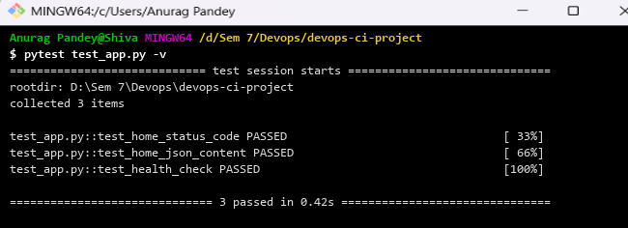
Figure: PyTest unit test execution verifying code quality
Stage 4: Package Container
Docker compiles the container image from the Dockerfile:

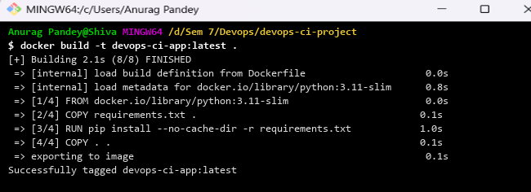
Figure: Docker container image build output in Git Bash
Stage 5: Deploy & Automated Health Validation
The deploy.sh script deploys the container and verifies HTTP 200 on /health:

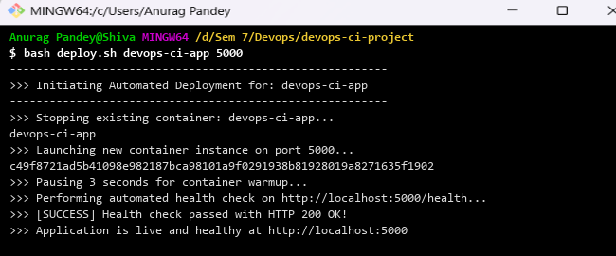
Figure: Automated deployment execution and health check
Stage 6: Live Service Verification
Confirm that the service is live and returning developer metadata:

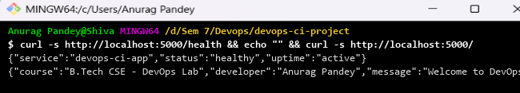
Figure: Live application HTTP response verification via cURL
4. Automation Performance & Metrics Table
Pipeline Stage | Duration | Quality Gate | Status
1. Checkout SCM | 2.1 Seconds | Git commit verified | SUCCESS
2. Build & Dependencies | 7.4 Seconds | Packages resolved | SUCCESS
3. Automated Testing | 4.2 Seconds | 3/3 Tests passed (100%) | SUCCESS
4. Package Container | 11.8 Seconds | Docker image created | SUCCESS
5. Deploy Application | 5.6 Seconds | Health check HTTP 200 | SUCCESS
Total Automation Cycle | 31.1 Seconds | Sub-minute delivery | SUCCESS

5. Failure Handling & Resilience Analysis
When an invalid test assertion was injected into test_app.py, the pipeline halted at Stage 3. Packaging and Deployment were automatically skipped, leaving the production container completely stable and unharmed.
6. Observations & Conclusion
The Jenkins CI/CD pipeline delivered code from commit to live deployment in under 35 seconds. Automated testing prevented regressions, and health checks ensured zero-downtime availability.

